SEED Labs – Linux Firewall Exploration Lab
This lab can be found on https://seedsecuritylabs.org/Labs_16.04/Networking/Firewall/

Task 1: Using Firewall
Iptables is used to set up, maintain, and inspect the tables of IP packet filter rules in the Linux kernel
You need to set up at least two VMs, one called Machine A, and other called Machine B.
I already had an existence ubuntu VM on VirtualBox, so I just duplicated the machine twice and renamed it to machine A and B
This can be done by right clicking on the existent VM then click clone.
Next rename the cloned VM and on clone type select full clone and finish
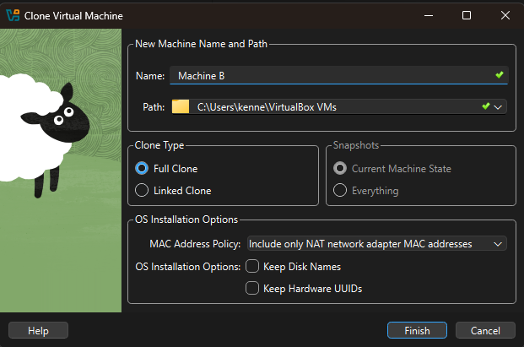
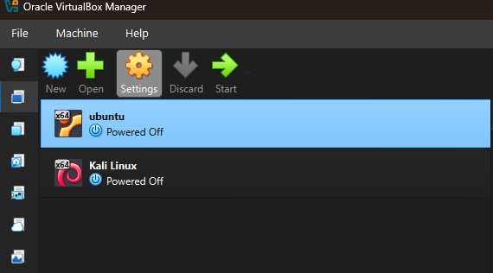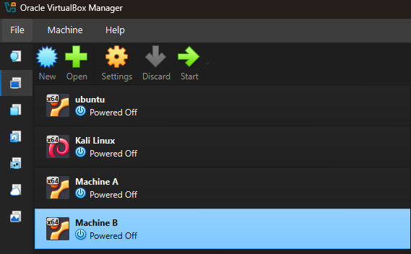
Once cloned check for connectivity using:
ip a / ip addr show – command that provides information on the network interfaces
Machine A
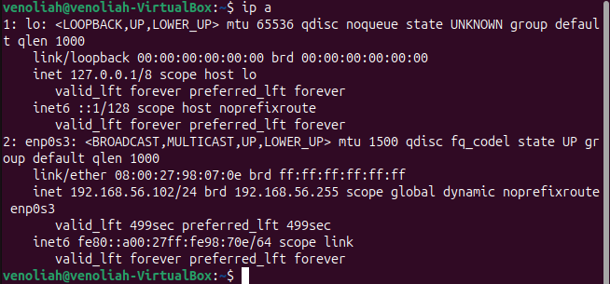
Machine B
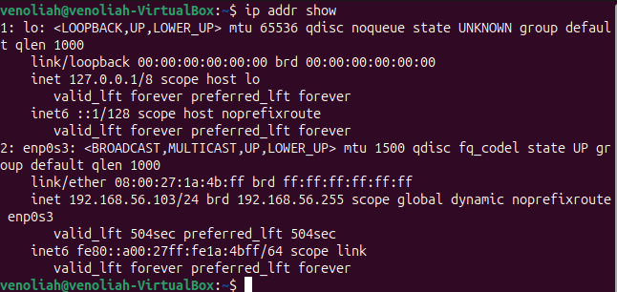
Ping <ip address> - Ping 192.168.56.103, Ping 192.168.56.102
• Prevent A from doing telnet to Machine B.
Telnet – insecure network protocol that was replaced by SSH for remote access to servers and network devices (port 23)
To prevent telnet, we need to block outgoing traffic on port 23
The general rule :
iptables -A <CHAIN> -p <PROTOCOL> [source/destination] [port] -j <ACTION>
sudo iptables -A INPUT -p tcp –dport 23 -j DROP
-A INPUT → traffic coming into your machine
-p tcp → telnet uses TCP
--dport 23 → destination port 23 (telnet)
-j DROP → block it
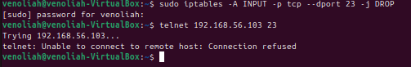
• Prevent B from doing telnet to Machine A.
sudo iptables -A INPUT -p tcp –dport 23 -j DROP
• Prevent A from visiting an external web site. You can choose any web site that you like to block, but keep in mind, some web servers have multiple IP addresses.
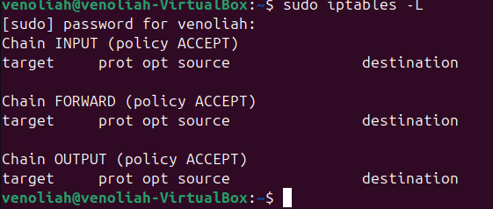 This command lists the rules is the table
For this task let’s try and block Substack
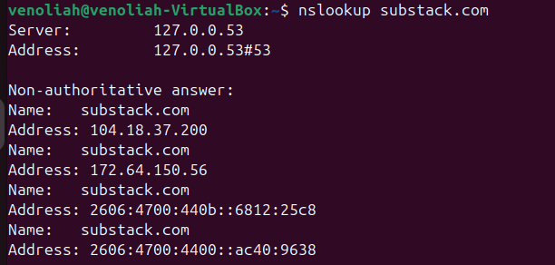
From the command above we get the multiple addresses that we need to block as below
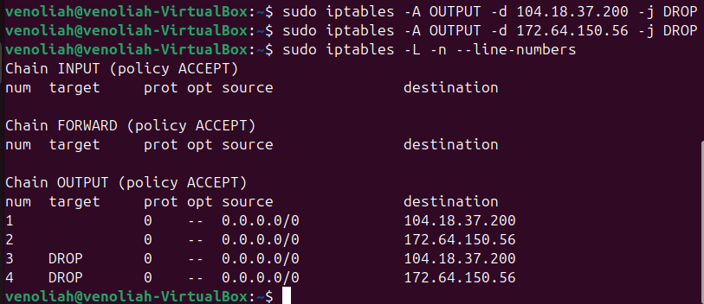
Once I blocked substack I tried to access it on firefox but the page just loaded on a loop without launching and timed out.

Task 2: Implementing a Simple Firewall
Loadable Kernel Module (LKM) and Netfilter – new mechanisms used to facilitate the manipulation of packets without rebuilding the kernel image
LKM – allows us to add a new module to the kernel at the runtime i.e inject netfilter code/module
Netfilter - facilitate the manipulation of packets by authorized users (Handles packet filtering, NAT, firewalling) – iptables
- Provides hook points in the kernel
Hook points - specific locations inside the Linux kernel network stack where packets are intercepted for processing.
Main hook points include:
  - PREROUTING - Every incoming packet hits here before any routing decision is made. Used for destination NAT (DNAT).
  - INPUT - packets destined for the local machine pass through here on their way to a local process (e.g. your web server).
  - FORWARD - packets passing through the machine (i.e. router) are intercepted here. The machine is not the final destination.
  - OUTPUT - packets generated by local processes leave through this hook before routing.
  - POSTROUTING - the last hook before a packet leaves on the wire. Used for source NAT (SNAT/masquerade).
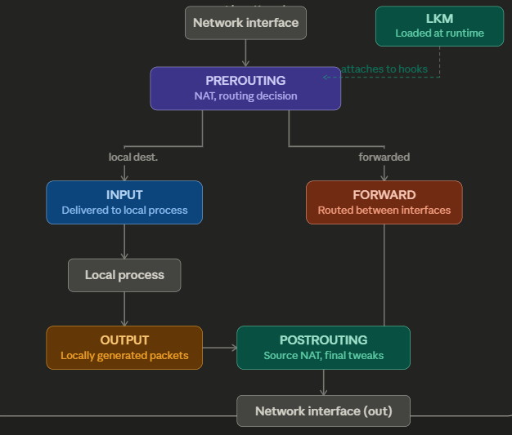
For this task I will implement the firewall rules on Machine A based on the guidelines in task 3 as well as additional rules of my own
3.1 Loadable Kernel Module
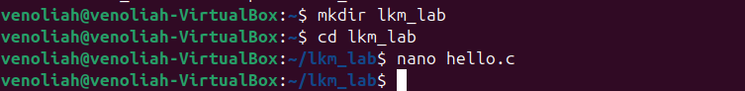
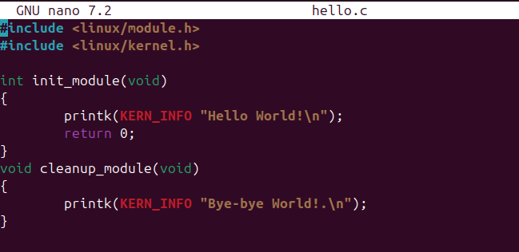
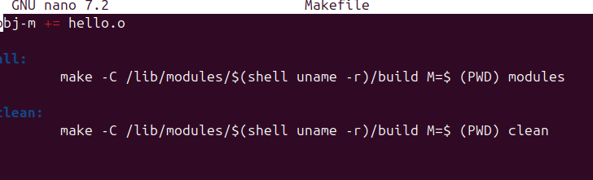
Once I created the hello.c file and the Makefile and run make I ran into an error
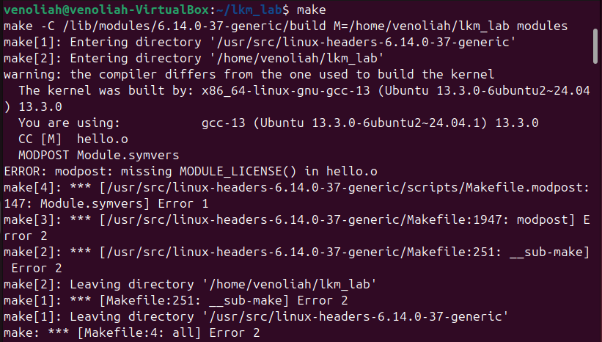
The major issue I realised was Linux kernel modules are required to declare their license using the MODULE_LICENSE() macro defined in linux/module.h
The metadata helps the kernel determine module licensing and whether the kernel should be marked as “tainted” when proprietary or unknown modules are loaded.
https://docs.kernel.org/admin-guide/tainted-kernels.html
I then corrected the hello file as below
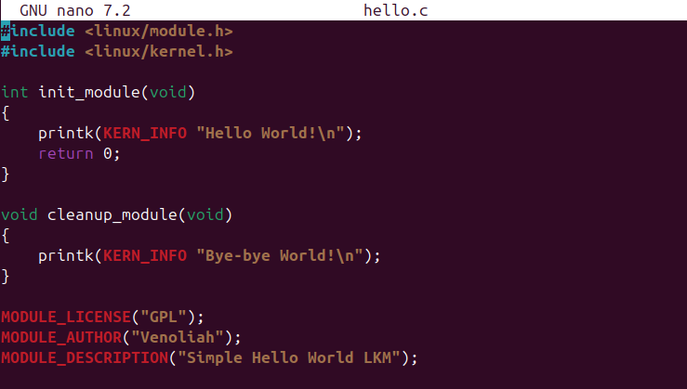
Before running make again, I run make clean to clear and earlier modules then run make again
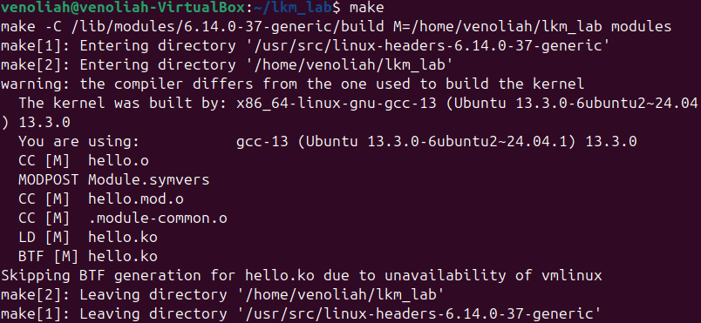
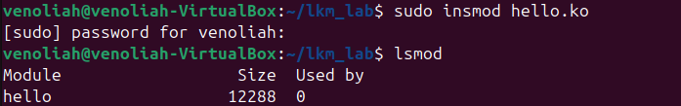
Modinfo hello.ko shows more information on the module
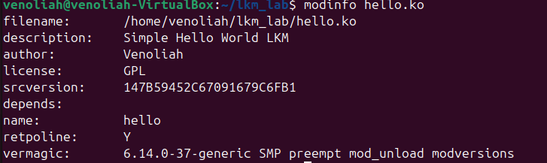

3.2 A Simple Program that Uses Netfilter
Netfilter allows kernel modules to register hook functions that intercept packets at predefined stages of the networking stack.
In this implementation, a hook function is registered at the NF_INET_PRE_ROUTING stage, enabling inspection of all incoming IPv4 packets before routing decisions are made.
The function can then decide to accept or drop packets based on firewall logic.
For this task I created another module netfilter.c
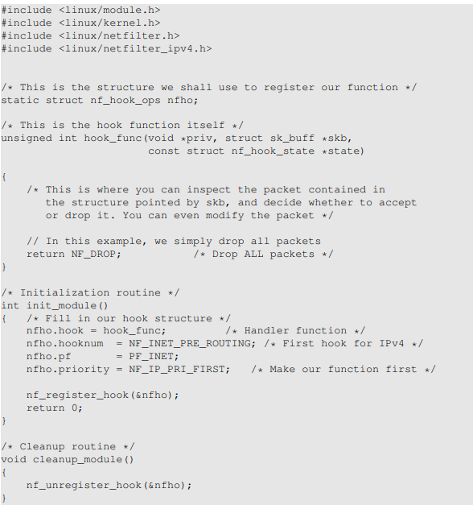
The code above was provided on the documentation but has depreciated thus need for minor changes to fit newer kernel versions
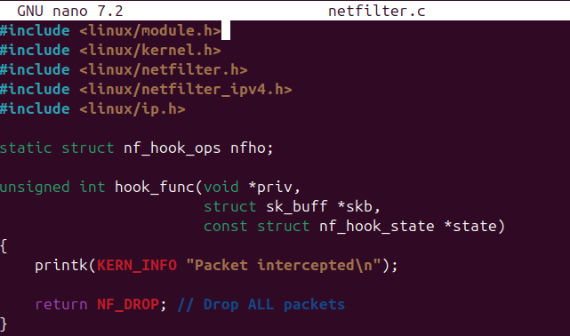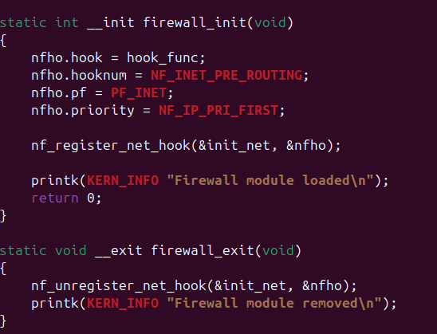
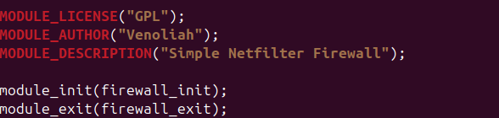
I then changed the Makefile (line 1) replaced the hello.o to netfilter.o
Then run make clean to clear earlier modules and rerun make
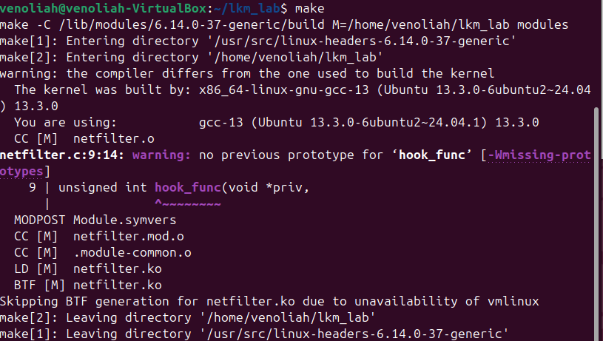
Next step is insmod netfilter.ko to load the module
I then tested the effectiveness of the module ‘firewall’ by trying a ping test as well as requesting a website (pinterest) address and the requests timed out as the network connectivity was lost as the function return NF_DROP; drops everything
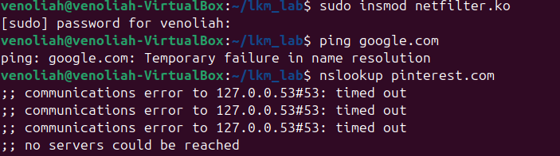
I also checked logs as the command was not allowed
To return to normal operations I removed the module to restore the system then did a ping test to prove restoration.
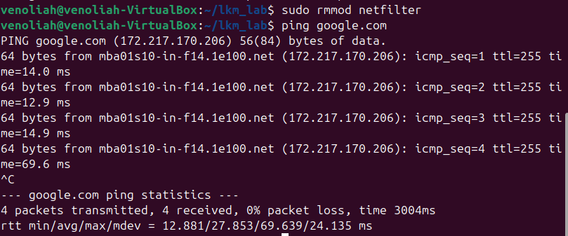
From the task above I did a drop all firewall

Task 3: Evading Egress Filtering
Egress filtering - blocks users inside of their networks from reaching out to certain web sites or Internet services
Ways to establish tunnels include:
SSH tunnels - uses an encrypted connection via Secure Shell to securely send traffic between two points
VPN tunnelling - Uses encrypted tunnels to connect networks or users (Internet protocol security, OpenVPN, WireGuard)
GRE tunnelling (Generic Routing Encapsulation)- Encapsulates packets inside other packets
- Egress filtering using SSH
I set up machine A to act as the firewall by setting up the required rules
First check the existing rules:
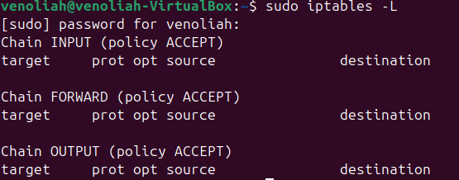
Currently, I have no rules configured as once I shutdown the VM the rules are not persistent by default therefore to maintain the rules you can save the machine state but, on your machine, you may be able to see the rules we had configured earlier.
Block all the outgoing traffic to external telnet servers
Telnet uses port 23 and since we are blocking outgoing traffic we will focus on the FORWARD chain
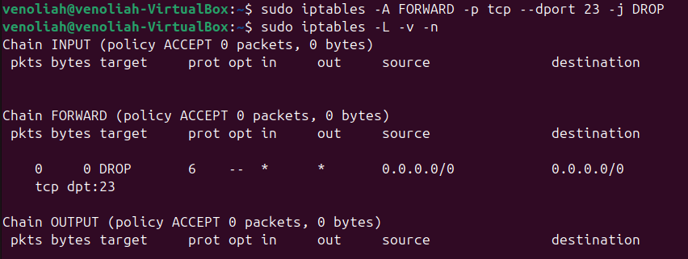
I then installed a telnet server on machine B to test the workability of the rule configured on machine A
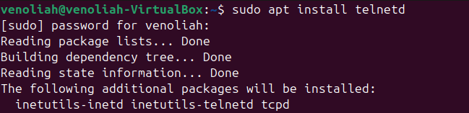
I then tried creating a telnet connection by using the Ip address of machine
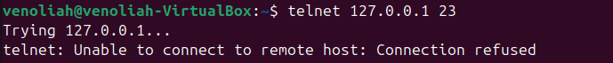

Block all the outgoing traffic to www.facebook.com
First, we need o retrieve the Ip addresses for the website by querying DNS – we can either use nslookup or dig
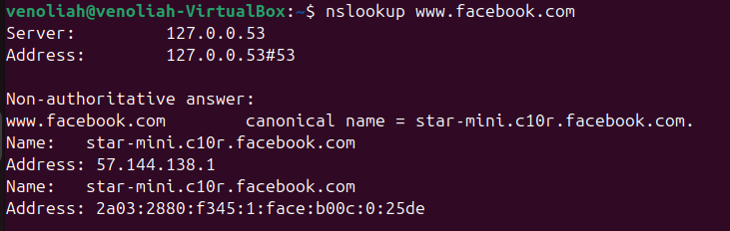
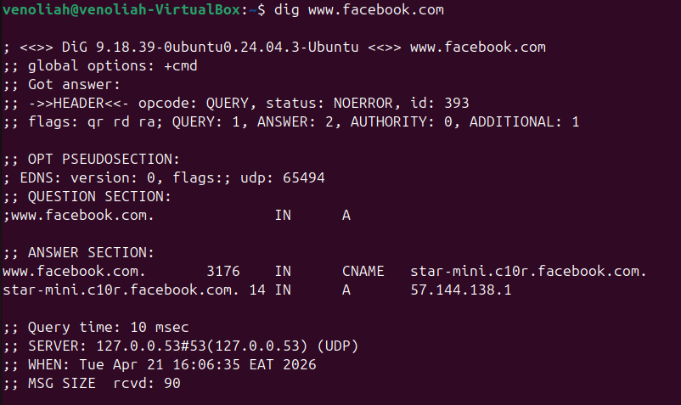
Using the addresses retrieved I then blocked the website (both Ipv4 and Ipv6)
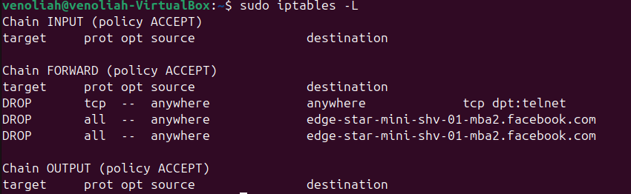
I then tried accessing facebook using my search engine and no connection was made

Task 3.a: Telnet to Machine B through the firewall
Cvcvvc

Task 3.b: Connect to Facebook using SSH Tunnel.
cccc

